**I. INTRODUCTION**

Multi-Domain Command and Control (MDC2) Trading Card Game is a 2-player, deck-building game that features air, ground, and cyber units. The goal of the game is to defeat the opposing player by reducing the opponent’s hit points (HP) to zero.

**II. PURPOSE:**

1. Demystify cyber terminology and concepts within the context of military operations; cyber is not "magic dust" and requires steps in a "kill chain" just like kinetic forces

2. Explore touchpoints and force tradeoff decisions between cyber and kinetic options (i.e. what to play vs. sacrifice)

3. Elicit a discussion between Airmen across various functional communities on how to build winning strategies

Figure 1. Multi-Domain Command and Control Card Game

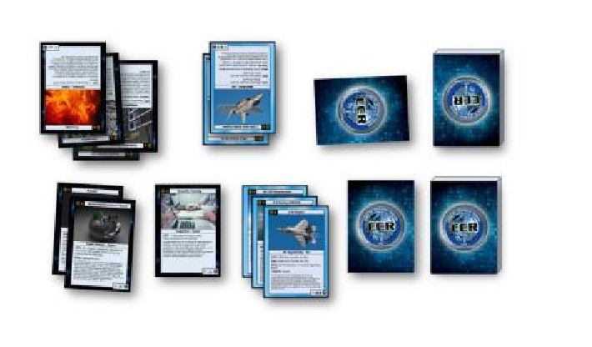

**III. EQUIPMENT DESCRIPTION**

The basic deck is comprised of 59 cards with various unit types and capabilities. This deck may be augmented with new cards creating more options for game play. Each player must have their own deck.

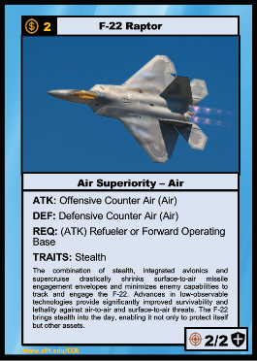

Card Type

Figure 2. Card Description

Name

Resource cost

Attack/Defense

Required Support

Traits

Description

Attack Points

Hit Points (HP)

Each card in the deck has some basic features as illustrated in Figure 2. These include:

* Name
* Resource Cost – the cost in number of cards for deploying this card
* Card Type
* Attack (ATK) – the type of attack
* Defense (DEF) – the type of defense
* Required Support (REQ) – the type of support required to be previous deployed in order to use this card
* Traits – provides game modifying effects
* Description – real world concept
* Attack Value – amount of damage inflicted on the enemy target (either offense of defense)
* Health Points (HP) – maximum damage the unit can receive before being removed from the playing area.

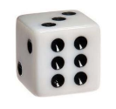Additionally, a standard six-sided die 1D6 die is required for randomness to game play.

# IV. RULES

This section describes general game play. In cases where the rules on the card conflict with the rules noted here, the cards should take precedence. Each of the following game phases represents a warfare concept. Figure 3 illustrates the head-to-head layout of the cards.

Figure 3. Game Layout

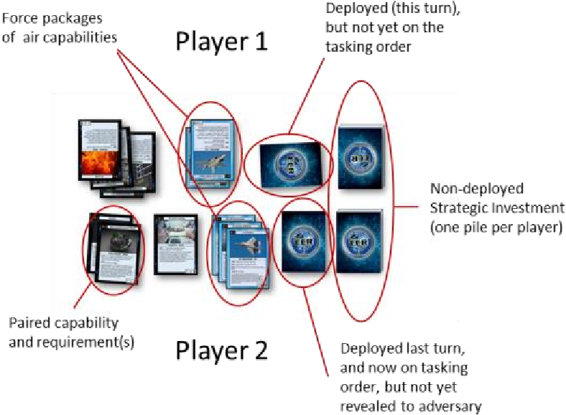

**A. Strategic Investment**

This phase represents strategic investment decisions from senior leaders into capabilities and technologies that may influence the game’s outcome. Out of the available cards, each player chooses 40 different units and types they will bring to the conflict. This resource pile must:

• Have exactly 40 cards   
 • Have no more than 2 of the same card

The resource pile can mix capability types (e.g. cyber and air cards) and experimentation is encouraged. Players will be more successful if they chose complementing capabilities. Cards not selected should be stored in the box as they will not be used during game play.

Each player selectively picks 6 cards from their resource pile for their starting hand. This group of cards signifies the capabilities a commander takes with them to the initial fight. The remaining cards are shuffled and placed face down on the table. Do not mix resource piles.

This phase requires planning and forethought ahead of actual game play to create a resource pile and initial capabilities that support a specific strategy.

**B. Force Deployment & Employment**

Each player starts with 20 hit points (HP). This can be tracked using pen and paper. Play alternates until a player reaches 0 hit points. If both players reach 0 HP on the same turn, there are no winners (i.e. mutually assured destruction). The junior ranking or younger player choose to go first or second.

On each turn, a player follows these steps:

*1. Acquire Resources*

Draw 3 cards from your resource pile and place in your hand (EXCEPT on the first turn for the first player). If a player does not have enough cards in the resource pile, the player takes 1 damage for each card that cannot be drawn (simulates war weariness).

*2. Take Action(s)*

a. Do nothing.

b. Deploy one or more capabilities:

Take a card from your hand and place it in front of you if you can pay the cost. Most cards are deployed face-down and horizontally to show that they were deployed on this turn, as most deployed cards cannot be used the same turn they are deployed (the exception to the rule is charge cards which can be used immediately). Optionally, the card may be played face up to intentionally let the opponent know what card was deployed.

Activation: Cards can be deployed without the necessary pre-requisites (REQ), but they cannot be activated or used without meeting the pre-requisite conditions. Deployed units do not satisfy pre-requisite conditions during current turn.

Cost: For each deployed card, you must pay its resource cost by immediately discarding the same number of cards from your hand as denoted on the deployed card. For example, to deploy a card with a resource cost of 2 means the player must discard two cards to pay for the deployed card.

c. Employ Capabilities:

From your deployed capabilities, turn a card face up where it will remain revealed for the rest of the game. Follow the instructions on the card. Attacking and defending are explained in further detail in the following section.

*3. Mobilize Capabilities:*

Turn all deployed cards vertically to show that they are now on the tasking order. This is primarily for units that have defensive capability so that they are usable for defense before the opposing player’s turn.

*4. Repair Units:*

Remove damage counters from all units (if used). Any partially damaged unit is fully repaired.

*5. End-of-Year (EOY) Accounting*

From the cards in your hand, discard down to 8 cards. The max carryover from one turn to the next is 8 cards.

**C. Home Station Readiness and Battlefield Intelligence**

The resource pile represents capability investments made at home station, but not yet ready to deploy. Readiness is determined randomly by deck shuffle. Cards in hand represent those capabilities ready to deploy. The orientation of the card has a specific meaning, as illustrated in Figure 3:

Horizontal cards – newly arrived in theater, but not yet on a tasking order

Vertical cards – deployed to theater and on a tasking order

Face-up cards – adversary has identified capability. Once revealed, the card remains face-up until discard.

Face-down cards – adversary cannot discern the type of capability deployed

**D. Attacking & Defending**

Attacking or defending with a capability requires the card to have an ATK or DEF designation. Sometimes, the ATK or DEF will have a specifier that denotes which type of units can be attacked—this will require looking at the type of card on the target.

An employed capability is destroyed when its HP drops to zero. Partial damage only needs to be tracked during a player’s turn and does not need to be tracked between player turns because step 4 of the turn order is to fully repair all damaged units.

When attacking, a mobilized capability can only attack one target (without modifiers) and the full amount of damage is applied. Some capabilities require a roll of the die and the requirement is specified on the card (i.e. must roll a 4 or higher).

Without defenses (vertical cards either face-up or face-down that can defend against the attacker), the opposing player represents the C2 element and is a valid target (with 20 HP to start). Excess damage (damage that decreases a card HP to less than 0) is ignored and is not applied to another target. Cards with a “—” for attack value cannot attack using attack points and “—” for HP cannot be killed by an attacker with attack points (target icon).

Priority (also known as “initiative”) determines which player and capability gets to play. Higher priority dictates the order of events. Attack and defend priority are as follows:

1. Unrevealed (face-down) Defender
2. Attacker
3. Defender

Unrevealed (face-down) Defender. In this case the attacker must engage the (now) revealed defender instead of the original target if possible (an exception may be if the defender card has stealth or a different attack qualifier [ground vs air]). If both attack values are greater than or equal to the hit points, both cards will be removed from the game.

Attacker: In this case the attack will be carried out against the target before revealed defensive asset(s) can engage. For example, a bomber would “get through” revealed defenses to successfully attack a Forward Operating Base (FOB) or C2 element (opposing player), however after the attack, the defender(s) could shoot the bomber down.

Defender: a revealed defender cannot intercept another aircraft (unless it is part of a force package), but it can counter-attack if it is being targeted. Therefore, if a F-22 attacks a (revealed) F-35 (and they can both detect stealth), then the F-22 will shoot down the F-35 (2 attack points vs 1 health point), but the F-22 will only be damaged (1 attack point vs 2 health points). If there is another available defender(s) they could also engage the damaged attacker. In this case the attacker could not fight back as all of their munitions would be expended on the first enagement.

**E. Advanced Rules and Concepts**

Given the diversity of cards, some of the cards can be played slightly differently in the *Take Action* turn of play. Due to the limited space available on the cards, they are not necessarily explicitly outlined on the cards.

1. General Characteristics

a. Pre-positioned – Cards with a “charge” can be used on the turn it is deployed, providing all requirements are met.

b. Single use – Cards denoted as “single use” are discarded once used. It may be recovered from the discard pile if another card has that ability.

c. Stealth – Cards with stealth cannot be targeted or defended from attacking if there is no unit or ability that can detect the stealth unit. Capabilities with stealth that are performing a counter-attack cannot be targeted by the attacker unless they can detect stealth.

2. Air-Specific Characteristics

a. Force Package – Air units may be put together in a force package by stacking the cards together. The purpose of doing so is to represent the effect of escort or defensive counter-air. When attacking, it forces the defender to engage the most suitable attacker. For example, an F-15 and B-52 force package attacks the opponent with (facedown) F16 defense—the F-16 can counter only the F-15 in the force package, letting the B-52 continue onto its target. If the F-15 and B-52 attack separately, the F16 can defend against both the F-15 and B-52 (because a defensive card can be used multiple times). Assembling or disassembling a force package can be done on the same turn. Support units (e.g. AWACS, KC-130) provide their capabilities whether they are part of force package or not. Air assets may also be packaged with ground units to provide fighter cover or close air support as applicable. When attacking and defending all assets in a force package can attack and defend (unlike a BCT described below).

b. Air Superiority – Units REQ this cannot be used unless there are no revealed opposing player assets that have ATK (Air). If used, they are still vulnerable to unrevealed defenders with ATK (Air), so escorts are recommended using Force Packages. Both players may have Air Superiority at the same time if the above conditions are met.

3. Ground-Specific Characteristics

a. Brigade Combat Teams (when deploying) – Cards denoted as BCT that are deployed together save logistical costs. For each additional BCT card deployed in the same turn, reduce the cost of deployment by 1. These are automatically deployed as a formed BCT (see below)

b. Brigade Combat Teams (when attacking & defending) – Cards denoted as BCT can form a combined arms group. When attacking, the BCT attacks a defender or the opposing player’s C2 element with the highest damage unit. When defending, the BCT defends using the unit of the BCT player’s choice. If a unit is lost within the BCT, the rest of the BCT survives.

4. Cyber-Specific Characteristics

Compromised Capabilities – For the purpose of the game, employing a cyber card requires a successful six-sided dice roll that can be modified by the attacking and defending player’s cards. If successful, the card can be put into play. On failure, the failed card is discarded AND any card(s) providing the pre-requisite must be re-rolled to stay in battlespace (account for all applicable modifiers). This is to model an adversary detecting the cyber attack and then reconfiguring their systems.

**V. EXAMPLE SCENARIOS**

This section describes some common scenarios that might be conceptually difficult during game play.

A. Air Force Packages & Engagement

As illustrated by Figure 4, this scenario describes the use of air packages and attack/defend engagement.

Figure 4. Air Force

Scenario

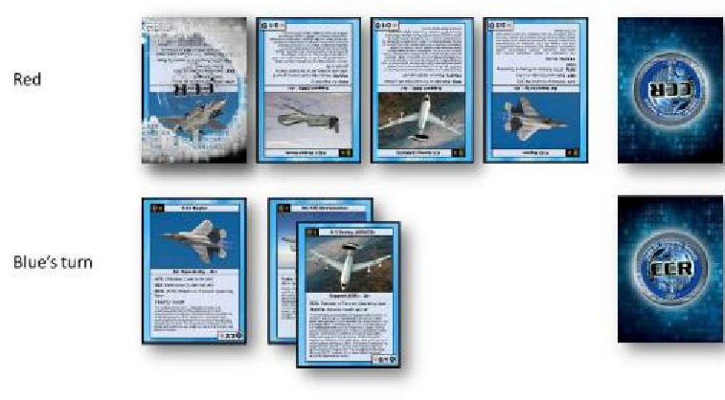

Blue has the following aircraft revealed:

1. A single F-22 Raptor
2. A force package containing a KC-135 Stratotanker and an E-3 Sentry

Red has the following aircraft:

1. A single F-22 Raptor
2. A single E-3 Sentry
3. A single RQ-4 Reaper
4. A single F-35 Joint Strike Fighter

(mobilized, but not revealed)

On Blue’s turn, Blue can target either Red’s RQ-4 or E-3. Red cannot use the F-22 to intercept because the F-22 is not packaged with either unit and it is revealed, so it has lower priority than Blue’s F-22. Red’s unrevealed F-35 can be used to intercept Blue’s F-22 because it is higher priority.

Blue’s F-22 (2/2) will shoot down Red’s F-35 (1/1) but will not be able to engage another target until next turn. Had Red’s F-35 survived, it would be revealed for the remainder of the game.

After Red’s F-35 is destroyed, Red can also use its F-22 to shoot down Blue’s F-22. Red’s F-22 will be destroyed and Blue’s F-22 will receive no damage.

## B. Cyber Engagement

As illustrated by Figure 5, this scenario describes the use of cyber capabilities.

Figure 5. Cyber

Scenario

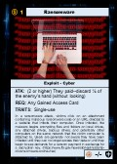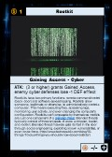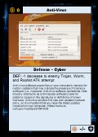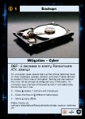

Red

Blue’s turn



Red has the following cyber defenses:

1. Backups   
2. Anti-virus

Blue has the following cyber capabilities:

1. Rootkit   
2. Ransomware

Blue must first Gain Access before he can activate her Ransomware. Typically, she would activate her Rootkit by rolling a 3 or higher (2/3 chance), but since Red has Anti-virus, Blue must roll a 4 or higher (1/2 chance), thus decreasing her odds of success. Next turn, Blue could have employed his Ransomware by rolling a 2 or higher (5/6 chance), but unfortunately Red has Backup, so Blue must roll a 4 or higher (1/2 chance). If successful, Blue may randomly discard half of Red’s hand representing assets that were lost.

**V. STRATEGY NOTES**

An air-heavy deck may use 4th generation aircraft early to provide an inexpensive offense and defense while building up to stealthier and long-range bombers that have 6 ATK on the opponents HP. Aircraft are fragile, so force packaging is critical to success.

A cyber-heavy deck primarily focuses on using cyber offensively to maintain information dominance and impair the opponent from being able to effectively execute their strategy. Some air assets may be needed to fend off kinetic attacks.

Land forces can pack a punch and be deployed inexpensively with BCTs. However, air cover will be needed in most scenarios.

**VII. FREQUENTLY ASKED QUESTIONS**

1. How many times can the same card attack in one turn?

Answer: Once

2. How many times can the same (or any) card defend?

Answer: No limit

3. Why are blank cards included in the deck?

Answer: Blank cards are intended to provide a player with the ability to develop new capabilities for game play. Use of these new capabilities must be agreed upon by both players as they may create game imbalances.

4. How many capabilities can be deployed/employed at one time?

Answer: You can deploy as many as you can afford based on resource cost. The resource cost indicates the number of cards you must discard (i.e. payment) to deploy this capability. You can employ as many capabilities as you currently have deployed and activated this turn.

5. Can cards be used multiple times if they are not identified as a single use card?

Answer: Yes. Capabilities generally exist until they are destroyed (such as air and ground assets) or they are discovered (cyber assets).

6. How do you ensure that cards being placed in the theater facedown are being paid for correctly at their cost?

Answer: While it is possible to cheat initially, at some point the asset will be revealed and the number of discarded cards can be compared to employed capabilities.

7. What are the advantages of creating/using a force package?

Answer: Force packages provide an escort capability and give defenders more options of where to take damage.

**VIII. CORRECTIONS**

1. APT Cyber Exploit – ATK should read “(4 or higher) On adversary’s next turn, they must randomly discard one card from their resource pile draw.   
Note: A re-attack is required each turn for this to be successful. If a re-attack (re-roll) fails, then this card must be discarded.

2. Spoofing (The Man in the Middle) – This must be re-rolled on each turn for the attack to be successful. If a re-attack is unsuccessful discard Spoofing card and then re-roll Sniffing or Scanning and Fingerprinting cards (that are paired with Spoofing) to see if they remain in play (account for all modifiers).